🡺**Day3 :Take value from user and display on next page** **using post method**

<html>

<head>

<body>

<h1>Form Demo</h1>

<form action="postprocess.php" method="post"

<table>

<tr>

<td>Name:</td>

<td><input type="text" name="txt1" required/></td>

</tr>

<tr>

<td>Age:</td>

<td><input type="text" name="txt2" min="1" max="10" required/></td>

</tr>

<tr>

<td>Email:</td>

<td><input type="email" name="txt3" required/></td>

</tr>

<tr>

<td><input type="submit"/></td>

<td><input type="reset"/></td>

</tr>

</table>

</form>

</body>

</head>

</html>

**🡺 postprocess.php**

<?php

$a=$_POST['txt1'];

$b=$_POST['txt2'];

$c=$_POST['txt3'];

echo "My name is $a and age is $b and email is $c";

?>

**🡺Output:**

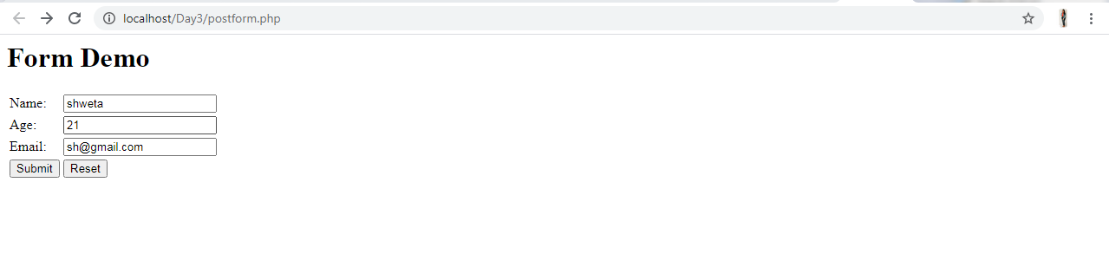



**Task 1 : Create a registration Form using Get and Post method and display data on next page**

**🡺Using Post Method**

<html>

<head>

<title>Registration Form</title>

</head>

<body bgcolor="pink">

<h1 align="center">REGISTRATION FORM</h1><br>

<form action="registrationgetprocess.php" method="post">

<table align="center">

<tr>

<td>First Name:</td>

<td><input type="text" name="txt1" required/></td>

</tr>

<tr>

<td>Last Name:</td>

<td><input type="text" name="txt2" required/><br></td>

</tr>

<tr>

<td>Gender:</td>

<td><input type="radio" name="txt3" value="Male">Male

<input type="radio" name="txt3" value="Female">Female</td>

</tr>

<tr>

<td>Address:</td>

<td><input type="text" name="txt4" required/></td>

</tr>

<tr>

<td>Email ID:</td>

<td><input type="email" name="txt5" required></td>

</tr>

<tr>

<td>Phone No.:</td>

<td><input type="number" name="txt6" required></td>

</tr>

<tr>

<td>Date Of Birth:</td>

<td><input type="date" name="txt7" required/></td>

</tr>

<tr>

<td><input type="submit"/></td>

<td><input type="reset"/></td>

</tr>

</table>

</form>

</body>

</<html>

**registrationgetprocess.php**

<?php

$a=$_POST['txt1'];

$b=$_POST['txt2'];

$c=$_POST['txt3'];

$d=$_POST['txt4'];

$e=$_POST['txt5'];

$f=$_POST['txt6'];

$g=$_POST['txt7'];

echo " First name :$a <br>" ;

echo " last name :$b <br>";

echo " Gender :$c <br>";

echo " Address :$d <br>";

echo " Email ID :$e <br>";

echo " Phone No. :$f <br>";

echo " Date Of Birth : $g <br>";

?>

**Output:**

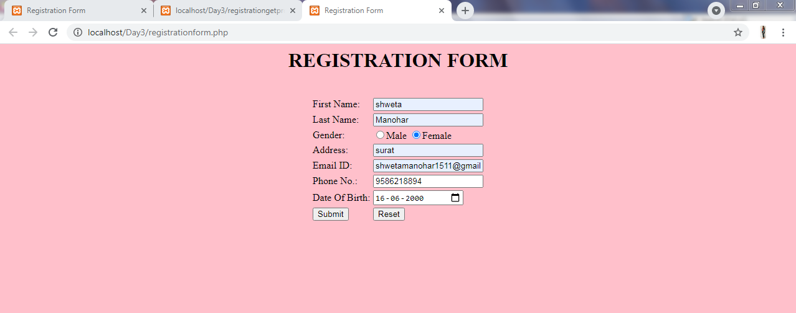

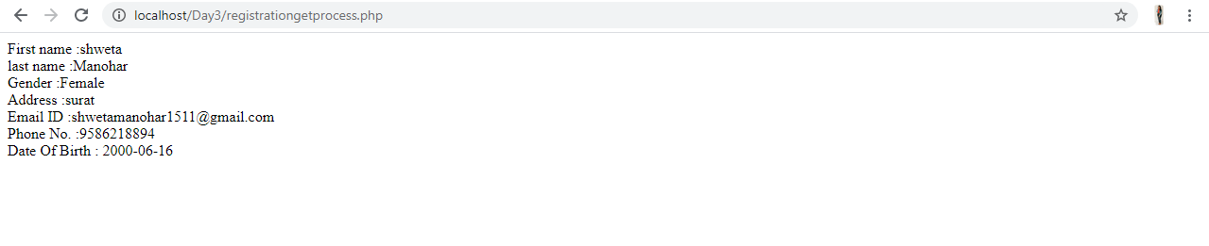

**🡺Using Get Method**

<html>

<head>

<title>Registration Form</title>

</head>

<body bgcolor="pink">

<h1 align="center">REGISTRATION FORM</h1><br>

<form action="registrationgetprocess.php" method="get">

<table align="center">

<tr>

<td>First Name:</td>

<td><input type="text" name="txt1" required/></td>

</tr>

<tr>

<td>Last Name:</td>

<td><input type="text" name="txt2" required/><br></td>

</tr>

<tr>

<td>Gender:</td>

<td><input type="radio" name="txt3" value="Male">Male

<input type="radio" name="txt3" value="Female">Female</td>

</tr>

<tr>

<td>Address:</td>

<td><input type="text" name="txt4" required/></td>

</tr>

<tr>

<td>Email ID:</td>

<td><input type="email" name="txt5" required></td>

</tr>

<tr>

<td>Phone No.:</td>

<td><input type="number" name="txt6" required></td>

</tr>

<tr>

<td>Date Of Birth:</td>

<td><input type="date" name="txt7" required/></td>

</tr>

<tr>

<td><input type="submit"/></td>

<td><input type="reset"/></td>

</tr>

</table>

</form>

</body>

</<html>

**registrationgetprocess.php**

<?php

$a=$_GET['txt1'];

$b=$_GET['txt2'];

$c=$_GET['txt3'];

$d=$_GET['txt4'];

$e=$_GET['txt5'];

$f=$_GET['txt6'];

$g=$_GET['txt7'];

echo " First name :$a <br>" ;

echo " last name :$b <br>";

echo " Gender :$c <br>";

echo " Address :$d <br>";

echo " Email ID :$e <br>";

echo " Phone No. :$f <br>";

echo " Date Of Birth : $g <br>";

?>

**Output:**



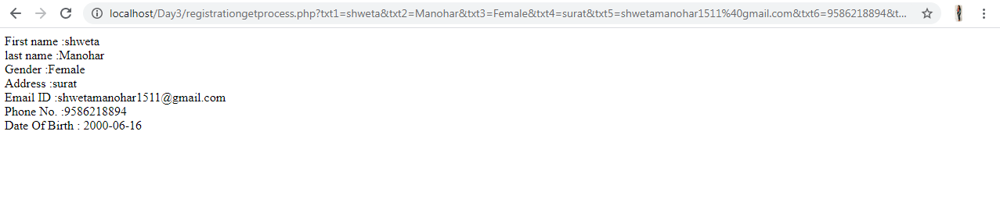

**Task 2: Take subject marks from user, count total marks, percentage and apply condition for marks >80% as first class >70% as second class >50% as Pass and fail give different background color for each condition.**

**🡺**<html>

<head>

<title>Student Mark sheet</title>

</head>

<body bgcolor="pink">

<h1 align="center">Student Subject Marks</h1>

<form method="post" action="studentmarksprocess.php">

<table align="center">

<tr>

<td>Java Marks :</td>

<td><input type="number" max="100" name="txt1" required></td>

</tr>

<tr>

<td>DBMS Marks :</td>

<td><input type="number" max="100" name="txt2" required/></td>

</tr>

<tr>

<td>Php Marks :</td>

<td><input type="number" max="100" name="txt3" required/></td>

</tr>

<tr>

<td>Python Marks :</td>

<td><input type="number" max="100" name="txt4" required/></td>

</tr>

<tr>

<td>Android Marks :</td>

<td><input type="number" max="100" name="txt5" required/></td>

</tr>

<tr>

<td><input type="submit"></td>

<td><input type="reset"></td>

</tr>

</table>

</form>

</html>

**🡺 studentmarksprocess.php**

<html>

<body>

<?php

$a=$_POST['txt1'];

$b=$_POST['txt2'];

$c=$_POST['txt3'];

$d=$_POST['txt4'];

$e=$_POST['txt5'];

echo "Java Marks : $a <br>";

echo "DBMS Marks : $b <br>";

echo "PHP Marks : $c <br>";

echo "Python Marks : $d <br>";

echo "Android Marks : $e <br>";

echo"<br>";

echo"<br>";

$Total=$a+$b+$c+$d+$e;

$percentage=($Total/500)*100;

echo " Total Marks is : $Total/500 <br>";

echo " Precentage is : $percentage% <br>";

if($percentage>80){

echo'<body style="background-color:green">';

echo"First Class";

}

elseif ($percentage>70) {

echo'<body style="background-color:orange">';

echo"Second Class";

}

elseif ($percentage>50) {

echo'<body style="background-color:purple">';

echo"Pass";

}

else{

echo'<body style="background-color:blue">';

echo"Fail";

}

?>

</body>

</html>

🡺 **Output**



